53-R-27

A Resolution to Recommend that The Ohio State University Rename Bricker Hall

Kelsey Lowman (for herself, Mustafa Abubakr, Greg Carson, Kenneth Harvey, Lulu Montes, Gabe Myers, and Sai Nune) introduced the following resolution to the Diversity and Inclusion Legislative Committee, where it passed. then to the Student Affairs Legislative Committee, where it passed, then to the Governmental Relations Committee, where it passed. Then, to the Steering Committee, where it passed, and to the floor, where it passed.

* * *

Whereas the Undergraduate Student Government represents all undergraduate students at The Ohio State University, and

Whereas John W. Bricker served as Ohio Attorney General (1933-1937), Governor of Ohio (1939-1945), United States Senator from Ohio (1947-1959), and Member of The Ohio State University Board of Trustees (1948-1969), and

Whereas the building that is currently named Bricker Hall is located at 190 N Oval Mall #203, Columbus, OH 43210, and

Whereas this building was honorifically named Bricker Hall in 1983 because of “his long service to the University”, and

Whereas Bricker Hall is the location that houses the Board of Trustees, the Office of Government Affairs, Internal Audit, the Office of Academic Affairs, the Office of Business and Finance, the Office of Outreach and Engagement, the Office of Research, the Office of Risk Management, the Office of University Communications, and the Office of the President, and

Whereas Doris Weaver was a Black student enrolled at the Ohio State University in the early 1930s as a Home Economics major, and

Whereas in 1933, Doris Weaver tried to enroll in a Home Economics course necessary to her major which required her to live in the “Grace Graham Walker House”, and

Whereas Doris Weaver was not permitted to live in the house with her white peers after the Home Economics department learned she was Black and so she took her case to the Supreme Court of Ohio, and

Whereas Ohio Attorney General John W. Bricker, in arguments before the Ohio Supreme Court, successfully defended the university’s position of separate but equal facilities for minority students, and

Whereas during the United States Senate’s consideration of the Housing Act of 1949, Senator John Bricker along with Senator Harry Cain of Washington introduced the Bricker-Cain amendment which called for a prohibition on segregation, and

Whereas the Bricker-Cain amendment was intended as a poison pill to defeat the bill by stopping some senators from supporting it if adopted and to stop executive agencies from creating regulations prohibiting segregation if not adopted, and

Whereas in 1953-54, Senator John Bricker introduced the Bricker Amendment in the U.S. Senate as a constitutional amendment which would have limited the president's power to enter into executive agreements and declared that no treaty could conflict with the Constitution, treaties could not be self-executing without the passage of separate legislation, and treaties could not give Congress legislative powers beyond those specified in the Constitution, and

Whereas many historians believe the reason this amendment was proposed was due to fear from some members of the U.S. Senate and the American Bar Association about the possibility segregation could be outlawed due to the United States’ adoption of the United Nation’s Charter, Genocide Convention, and Universal Declaration of Human Rights, and

Whereas John Bricker’s segregationist actions, policies, and beliefs were specifically espoused to prevent people of color from accessing the same resources and educational opportunities that white individuals were granted, and

Whereas former Ohio State President Michael Drake said in his 2020 Vision Speech that, “The Ohio State University must be a national model of inclusiveness and diversity. From our student community to the hiring and promotion of faculty and staff, diversity must be recognized and celebrated as they find in core strength”, and

Whereas in her 2021 State of the University, Ohio State President Kristina Johnson said that, “it is time to move beyond access to truly reflect the people we serve — to become a place that offers every Ohioan — of any gender, sexual orientation, race, color, religious belief or national origin — their very best opportunity at an amazing life”, and

Whereas according to the Fifteenth Day Enrollment Report for the Spring 2021 semester, 9.35% of students at The Ohio State University identify as African American, and

Whereas according to the Mission, Vision, Values, and Goals of The Ohio State University, the university understands “that diversity and inclusion are essential components of our excellence”, and

Whereas having a university building named after John Bricker, especially one that holds the Board of Trustees and Office of the President, is incongruent with the university’s stated values of diversity and inclusion, and

Whereas the University of California, Berkeley removed the name of John Boalt from their Law School in January 2020 for his role in Chinese Exclusion Act of 1882 after concluding that his “positive contributions to the university do not appear to outweigh this legacy of harm”, and

Whereas Indiana University recently formed a committee to review the name of Jordan Hall, named for David Starr Jordan, a former zoology professor and university president during the late 1800s who supported eugenics, and

Whereas “institutional renaming is only a first step towards universities examining their own racist legacies and becoming more inclusive”, and

Whereas student organizations Buckeyes First, Undergraduate Black Law Student Association, and the Morrill Scholars Student Advisory Council all support the renaming of Bricker Hall, and

Whereas the University Senate Diversity Committee supports changing the name of Bricker Hall.

Therefore, Let it Be Resolved that the Undergraduate Student Government supports the name change of Bricker Hall and calls on the university to rename it, and

Let it Further Be Resolved that the Undergraduate Student Government recommends that the building be renamed to honor Doris Weaver, and

Let it Further Be Resolved that the Undergraduate Student Government urges the university to create a standardized process for the naming and renaming of buildings and spaces on campus.

Floor Vote: Passed with General Consent

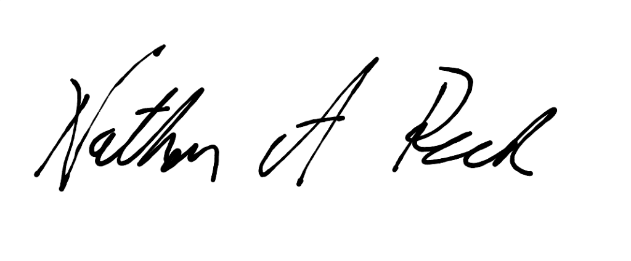
_____________________________ ________________________________
Roaya Higazi Nathan Rush
President Speaker of the 53rd General Assembly

Date Adopted: March 3, 2021

https://library.osu.edu/site/archives/2012/12/14/twelve-days-of-buckeyes-six-whove-attended-osu-have-led-as-ohios-governor-too/
https://www.innovations.harvard.edu/sites/default/files/hpd_1102_hirsch.pdf
https://www.prrac.org/pdf/HUD50th-CivilRightsTimeline.pdf
https://www.jstor.org/stable/24911655?seq=1#metadata_info_tab_contents
https://carmencollection.osu.edu/story/denied-campus-housing-based-color-and-tradition
https://casetext.com/case/state-ex-rel-v-trustees-2
https://oaa.osu.edu/mission-vision-values-and-core-goals
https://news.berkeley.edu/2020/01/30/boalt-hall-denamed/
https://www.insidehighered.com/news/2020/07/06/campuses-remove-monuments-and-building-names-legacies-racism
https://president.osu.edu/speeches/sotu2021
https://www.osu.edu/features/2015/2020-vision.html
https://oesar.osu.edu/pdf/student_enrollment/15th/enrollment/15THDAY_SPRING_2021.pdf
https://www.nature.com/articles/d41586-020-02393-3
Appendix B
Appendix C
Appendix D
Appendix E
Appendix A

