Whereas the Undergraduate Student Government represents all undergraduate students at The Ohio State University; and

Whereas Article IV, Section B, Subsection b(iii) of the Undergraduate Student Government Organizational Bylaws states, “The Chair of the Black Caucus shall be responsible for: Appointing Vice Chairs to the respective Black Caucus committees, including filling vacancies, should such arise”; and

Whereas Article IV, Section A, Subsection c of the Undergraduate Student Government Organizational Bylaws states. “The duties of the Black Caucus shall be divested upon the committees of Academic Affairs, Community Relations, Policy, Student Experience, and Systems and Operations, and any other committees which the Chair of the Black Caucus deems necessary to apportion therein”; and

Whereas all appointees for the 2026-2027 Executive Board have participated in a rigorous application process that included written applications, interviews, and peer guidance. In addition, all appointees have at least a year of experience in the Black Caucus, including in their respective committee of nomination. All have met the standard laid out in the application process and demonstrated their ability to serve students; and

Whereas Erin Pernell has been nominated to serve as Vice Chair of the Academic Affairs Committee for the 2026–2027 academic year; and

Whereas Eliora Teferi has been nominated to serve as Vice Chair of the Community Relations Committee for the 2026–2027 academic year; and

Whereas Alena Ferrell has been nominated to serve as Vice Chair of the Policy Committee for the 2026–2027 academic year; and

Whereas Emmanuela Yeboah has been nominated to serve as Vice Chair of the Student Experience Committee for the 2026–2027 academic year; and

Whereas Mykaila Davis has been nominated to serve as Vice Chair of the System & Operations Committee for the 2026–2027 academic year; and
Therefore, Let it Be Resolved that the Undergraduate Student Government General Assembly hereby confirms the aforementioned nominees to serve on the Undergraduate Black Caucus Executive Board for the 2026-2027 academic year upon passage of this resolution, granting them the responsibilities to hold their position in the interests of serving the student body.

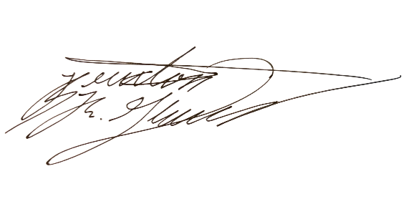
Floor Vote: Aye: 18 Nay: 0 Abstain: 0 Present: 18

_________________________________ ________________________________
Christopher Cade Braxton R. Glover
President Speaker of the 59th General Assembly

Date Adopted: _____________________ Date Terminated: ___________________

