Whereas the Undergraduate Student Government represents all undergraduates at The Ohio State University; and

Whereas Article VI, Section C, Subsection A(e)(i) of the Undergraduate Student Government Constitution states, “The President and Vice President shall jointly retain the authority to appoint a Senior Staff and Executive Cabinet Directors to act as an extension of executive authority”; and

Whereas Article VI, Section C, Subsection A(e)(i)(1) states, “Nominations by the President and Vice President shall be confirmed or rejected by the General Assembly by a majority vote and shall originate in the form of a resolution to the Oversight Committee of the General Assembly”; and

Whereas all nominees for Executive Cabinet Committee Directors underwent a rigorous and competitive application process, including submission of a written application, participation in an interview, and completion of follow-up questions to assess their qualifications and vision for serving the student body; and

Whereas all nominees have reviewed and agreed to abide by the expectations, responsibilities, and standards outlined for Executive Cabinet Committee Directors; and

Whereas Jack Higgins has been nominated to serve as Director of Internal Operations for the 2026–2027 academic year; and

Whereas Sofia Aviles has been nominated to serve as Director of Community Relations for the 2026–2027 academic year; and

Whereas Anika Dhingra has been nominated to serve as Director of Data Management for the 2026–2027 academic year; and

Whereas Alena Morales has been nominated to serve as Director of Recruitment for the 2026–2027 academic year; and

Whereas Erin Ciarfella has been nominated to serve as Co-Director of Academic Affairs for the 2026–2027 academic year; and

Whereas Lily Turner has been nominated to serve as Co-Director of Academic Affairs for the 2026–2027 academic year; and

Whereas Greta Salmon has been nominated to serve as Director of Governmental Relations for the 2026–2027 academic year; and

Whereas Ayla Gerber has been nominated to serve as Director of Health and Safety for the 2026–2027 academic year; and

Whereas Marin Funderburg has been nominated to serve as Director of Justice and Equity for the 2026–2027 academic year; and

Whereas Emily Potoczak has been nominated to serve as Co-Director of Student Affairs for the 2026–2027 academic year; and

Whereas Hallie Frigge has been nominated to serve as Co-Director of Student Affairs for the 2026–2027 academic year; and

Whereas Miles Meisse has been nominated to serve as Co-Director of Sustainability for the 2026–2027 academic year; and

Whereas Millena Desta has been nominated to serve as Co-Director of Sustainability for the 2026–2027 academic year; and

Whereas Ethan Lucas has been nominated to serve as Director of Events & Coordination for the 2026-2027 academic year.

Therefore, Let It Be Resolved that the Undergraduate Student Government General Assembly hereby confirms the aforementioned nominees to serve as Executive Cabinet Committee Directors for the 2026–2027 academic year, effective immediately upon passage of this resolution, and charges them with upholding the responsibilities, expectations, and standards of their respective roles in service to the undergraduate student body.

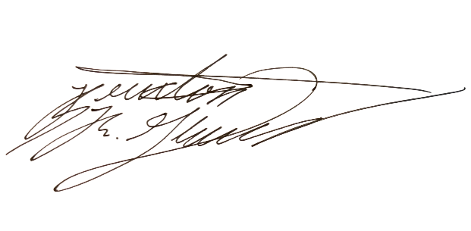
Floor Vote: Aye: 18 Nay: 0 Abstain: 0 Present: 18

_________________________________ ________________________________
Christopher Cade Braxton R. Glover
President Speaker of the 59th General Assembly

Date Adopted: _____________________ Date Terminated: ___________________

Sofia Aviles Resume - Director of Community Relations
Alena Morales Resume - Director of Recruitment
Erin Ciarfella Resume - Co-Director of Academic Affairs
Lily Turner Resume - Co-Director of Academic Affairs
Marin Funderburg Resume - Director of Justice & Equity
Emily Potoczak Resume - Co-Director of Student Affairs
Hallie Frigge Resume - Co-Director of Student Affairs
Millena Desta Resume - Director of Sustainability
Ethan Lucas Resume - Director of Events & Coordination

